Online Fault Detection in PV Systems

Ansh Prasad
Dept. of Electrical Engineering
Dayalbagh Educational Institute Agra, India
anshprasad01@gmail.com

Abstract: The rapid adoption of solar energy as a sustainable alternative to fossil fuels has necessitated advancements in system reliability and fault detection. The United Nations has set a goal to ensure global access to affordable, sustainable, and clean energy, underscoring the importance of optimizing renewable energy systems. [1] This study presents a machine learning-based approach for early fault detection in solar photovoltaic (PV) systems, utilizing real-time data collected from an educational institute’s rooftop solar installation. The dataset comprises an average of 144 daily instances, captured at 10-minute intervals (or more frequently if warning logs occur), over the period from May 2022 to May 2023. A subset of parameters, selected from a broader dataset, was analysed to explore seasonal and operational variations in the system’s performance.
The project focuses on evaluating the energy performance of the PV system and training machine learning models to detect anomalies indicative of potential faults at an early stage. This proactive approach aims to enhance the operational efficiency and reliability of solar PV systems, contributing to the global transition toward sustainable energy solutions.
INTRODUCTION
The increasing global demand for clean and sustainable energy has led to a significant rise in the adoption of Solar Photovoltaic (PV) systems. Effective monitoring and fault detection in these systems are critical to ensure their efficiency and reliability. This project discusses a comprehensive approach to studying and improving the performance of PV systems by leveraging advanced methodologies and technologies.
Typically the energy flow in solar (PV) system, during the day, solar panels capture sunlight and convert it into electricity, which flows directly to power appliances if they are running. Any excess energy, beyond what is immediately needed, is either stored in batteries for later use or exported to the grid if net metering is enabled. In cloudy or low-sunlight conditions, solar generation
Tanvi Malik
Dept. of Electrical Engineering
Dayalbagh Educational Institute Agra, India
tmalikagr04@gmail.com

decreases; the system compensates by drawing energy from the batteries or, if needed, from the grid. At night, when solar panels are inactive, stored energy from the batteries is used to power appliances. If the batteries are depleted or not installed, the system seamlessly switches to the grid to ensure uninterrupted power. In hybrid setups, smart management systems prioritize battery use first, followed by the grid as a backup. Throughout the process, sensors monitor energy production, storage levels, and consumption, optimizing efficiency while sending alerts for maintenance or faults. This ensures reliable, sustainable energy flow under all conditions.
Solar Photovoltaic (PV) system from which we received data, as described in [1], comprises a 40 kWp PV array, a 96 kWh battery storage unit, a 40 kVA grid-support conditioner (GSC), and a data acquisition system. The PV array, tilted at 27° and facing south, consists of 170 Wp monocrystalline silicon modules grouped into 24 strings, each with 10 modules, achieving a system voltage of 240 VDC. Connected to the same DC bus is a string of 120 low-maintenance lead-acid batteries rated at 2V, 400Ah each. An integrated inverter with a Maximum Power Point Tracking (MPPT) charge controller enables continuous data logging with a 10-minute resolution, facilitating detailed energy flow analysis. Over a one-year study, the system generated an annual energy output of 31.35 MWh, with peak generation occurring in April and May due to favourable environmental conditions such as higher solar insolation and cleaner modules [1].
Fault detection in PV systems is a crucial component of their operation. As highlighted in [2], an effective fault detection methodology involves comparing measured AC power production with predictions from a simple yet accurate model. Significant deviations between these values are used to identify faults. Unlike complex simulation-based or artificial intelligence-dependent models, this approach is low in complexity and requires minimal prior knowledge, making it adaptable to various PV installations. This model can also be automated to calculate normal operational limits and detect abnormal behaviour, ensuring the system remains reliable and efficient.
For utility-scale solar installations, which can produce over 50 MW of electricity, maintaining efficiency and minimizing maintenance costs is a challenge. Conventional monitoring systems rely on detailed analytics of parameters such as voltage, current, temperature, and irradiance. Machine learning-based techniques, as discussed in [3], are now widely used to automate performance monitoring, detect faults, and optimize the operation of large-scale PV arrays. These algorithms reduce the burden on human operators while enhancing the overall performance of photovoltaic systems under varying conditions [3].
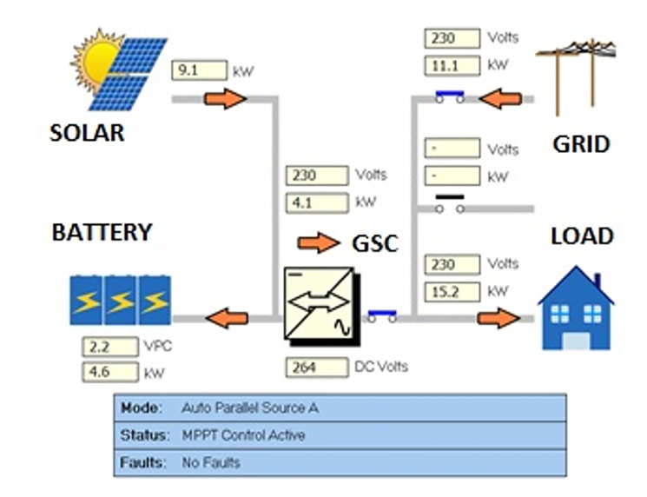
Fig.1 Structure of PV System (real-time interface)
MOTIVATION TO SELECT THE PROBLEM
The increasing reliance on solar photovoltaic (PV) systems for sustainable energy production has emphasized the need for reliable fault detection and system optimization. Faults in solar PV systems—caused by issues such as shading, soiling, inverter failures, and wiring defects—can lead to significant energy losses, increased downtime, and higher maintenance costs.
Traditional fault detection methods, including manual inspections and basic monitoring systems, are inadequate for addressing the dynamic and complex nature of solar PV operations. These methods often fail to detect faults promptly, leading to prolonged inefficiencies. With advancements in data analytics and machine learning, it has become possible to leverage high-frequency operational data to build predictive models for early fault detection. This study aims to utilize real-time data to identify fault patterns and classify system states, thereby improving system reliability and reducing operational disruptions
LITRATURE REVIEW

METHODOLOGY
This study proposes a data-driven approach to enhance the reliability and operational efficiency of solar PV systems by leveraging real-time data and machine learning for early fault detection. The steps draw inspiration from established methods, leveraging real-time data, advanced statistical techniques, and machine learning for robust fault detection and analysis.
- Data collection
Data was collected from a rooftop PV system installed at an educational institute, with a 40 kWp PV array integrated with battery storage and grid support. The dataset spans May 2022 to May 2023 and includes measurements taken at 10-minute intervals, such as:
 | Parameter | Description
1 | Date | Date of log data
2 | Time | Time of log data
3 | Description | Status or description of the data log
4 | Trigger | Changes that occurred triggering the log
5 | Inv kW Sum (kW) | Inverter power sum
6 | Load kW Sum (kW) | Load power sum
7 | Solar kW (kW) | Solar power generated
8 | Ambient Temp (°C) | Ambient temperature
9 | Solar Radiation (W/m²) | Solar radiation (DNI)
10 | Inv Exp kWh | Inverter export energy
11 | Inv Imp kWh | Inverter import energy
12 | Src A Exp kWh | Source A exported energy
13 | Src A Imp kWh | Source A imported energy
14 | Src B Exp kWh | Source B exported energy
15 | Src B Imp kWh | Source B imported energy
16 | Site kWh (calc) | Energy expended on site
17 | Batt Exp kWh | Battery exported energy
18 | Batt Imp kWh | Battery imported energy
19 | Solar kWh | Solar energy generated

- Data Analysis
Figure 2.The system was operational for 345 days, with the remaining days allocated to scheduled and unscheduled maintenance. Over the course of the year, the system generated a total of 31.35 MWh of energy. Higher energy yields were observed in April and May, while February, March, July, and August also saw a larger share of energy production. This was primarily due to higher insolation values during these months, combined with favourable conditions such as moderate cell temperatures (ranging from 27°C to 37°C) and cleaner modules in the later months compared to the earlier part of the year.
Figure 3 illustrates the average monthly radiation input in Wh/m²/day, while Figure 5 shows the import and export of battery energy. Battery export refers to the energy transferred from the battery to the local load, while battery import indicates the energy drawn from the grid and solar to charge the batteries. The main objective of battery storage in the microgrid is to ensure a reliable supply to the load. The priority for supplying power is as follows: solar energy is the first source, followed by grid energy if solar output is insufficient, and lastly, battery energy is used in rare cases. As a result, battery export is typically much lower than battery import. Even when the battery is fully charged, it continues to receive a constant trickle charge from both solar and grid energy during the day, with only the grid providing power at night. This trickle charge is in addition to the energy needed to fully charge the battery, which explains the higher energy input compared to output.
Figure 6 depicts the behavior of site load (in kWh) and corresponding solar generation (in kWh) over the study period. During the winter months, when load slightly exceeds generation, the situation improves in January, February, and March, with load consistently outpacing generation. Finally, Figure 7 presents the grid import and export trends in the system, which align with the patterns observed in Figure 6. As load and generation come closer to balance, grid export tends to increase.

Fig.2 Monthly energy yield(Y_{E}).

Fig.3 Average monthly Solar irradiation.

